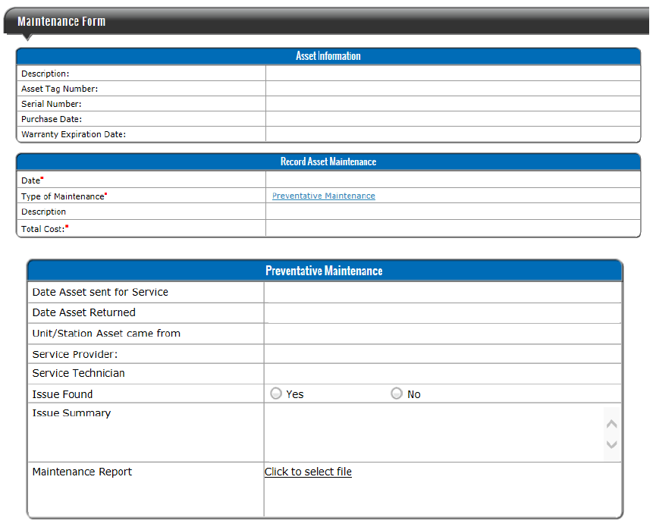 **Asset Preventative Maintenance Form**